4.2 Configure and Verify NTP operating in client and server Mode

**NTP (Network Time Protocol)**

* NTP is a term which is stands for Network Time Protocol, use to provide Time.
* NTP is used to allow network devices to synchronize clocks with central source clock.
* NTP is very important for network devices like Routers, Switches, Severs or Firewalls.
* NTP make sure logging information and timestamps have the accurate time and date.
* Network Time Protocol INTP) is runs over User Datagram Protocol (UDP).
* Network Time Protocol (NTP) is a protocol used on networks to maintain clock time.
* Network Time Protocol (NTP) uses a hierarchical system of time sources.
* Network Time Protocol (NTP) uses client-server architecture to work.
* Network Time Protocol (NTP) uses a well-known UDP port number 123.
* Currently there are two versions of NTP version 3 and NTP version 4.
* A Network Time Protocol (NTP) server is also referred to as an NTP Master.
* Router can be configured in three modes Server, Client and Server/Client mode.
* By default, Router works in Network Time Protocol (NTP) Server/Client mode.
* Stratum defines the reliability and accuracy of Network Time Protocol source.
* Network Time Protocol (NTP) uses of stratum 0 to stratum 15 for NTP sources.
* One 1 is the most reliable and 15 is the worst Network Time Protocol source.
* Stratum 0 represents Atomic clock and not used in Cisco Router or Cisco Switch.
* Stratum 1 to 15 are valid levels and used in Cisco Routers and Cisco Switches.
* Stratum 16 represents Network Time Protocol (NTP) is not synchronized.
* Default stratum level of Cisco Router's or Switches internal clock is 8.
* Syslog messages timestamp using the Network Time Protocol (NTP).

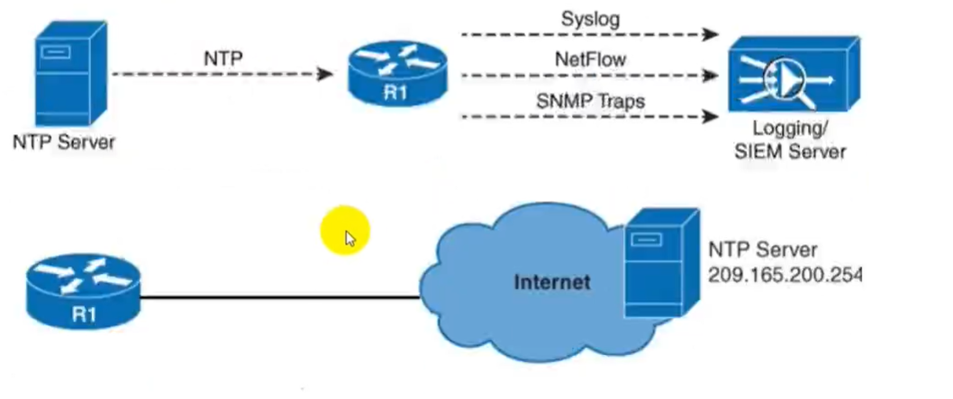

**NTP Stratum:**

* NTP, stratum levels define the distance from the reference clock.
* A Stratum-O device that is assumed to be most accurate and it has no delay.
* Network Time Protocol Stratum-0 servers cannot be used on the network.
* For example, a device with Network Time Protocol stratum 1 is very accurate device.
* Network Time Protocol (NTP) Stratum 1 might have an atomic clock attached to it.
* Another NTP using stratum 1 server to synchronize own time would be a stratum 2 device.
* Because stratum 2 is one Network Time Protocol (NTP) hop further away from the source.
* Configure multiple NTP servers, client will prefer NTP server with lowest stratum value.

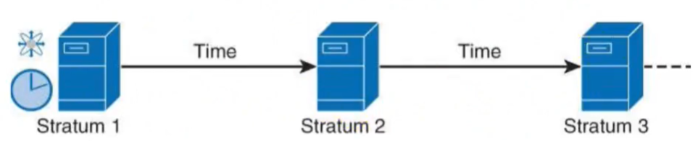

**NTP Architecture:**

* NTP uses stratums I to 16 to define clock accuracy.
* A lower NTP stratum value represents higher accuracy.
* Clocks at NTP stratums 1 through 15 are in synchronized state.
* Clocks at Network Time Protocol are not synchronized.
* Stratums is like TTL number decreases every hop a packet passes by.

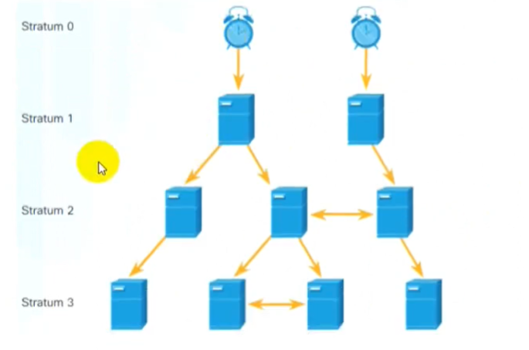

**NTP Modes:**

* Cisco Routers and Cisco Switches can use four (4) different NTP modes.
* NTP Server, NTP Client, NTP Server/CIient and NTP Peer or Symmetric Active mode.

**NTP Server Mode:**

* NTP server is a network device, which is running NTP service.
* NTP server is configured to provide Time information to NTP clients.
* NTP server provide only Time information to NTP Clients.
* NTP server never accept time synchronization information from other devices.
* NTP server mode router reads time from NTP source or uses its own clock as NTP source.

**NTP Client Mode**

* NTP Client mode, Router only receives NTP updates.
* NTP Client does not advertise received updates.
* NTP Client uses them to synchronize its own clock.

**NTP Server/Client Mode:**

* NTP Server/Client, Router receives updates from NTP server.
* NTP Server/Client also advertises them from its own interfaces.
* NTIP Server/Client mode Cisco Router or Switch plays both roles.
* As NTP Client, it receives NTP updates & as NTP Server, it advertises NTP updates.
* NTP Server/Client mode, as an NTP Server, instead of using its own NTP Source.
* NTP router uses received NTP updates from other NTP server.
* NTP Server advertise the NTP updates to other NTP Clients.
* This feature allows using a single centralized NTP source at NTP Server.

**NTP Peer Mode:**

* An NTP peer does not have authority over the other.
* In NTP peer mode, each device can provide time synchronization to other.
* So, one can synchronize the other in case of failures.

**NTP Master:**

* To make a router to become an authoritative NTP server.
* Where internal devices can synchronize use NTP master command.
* NTP master command tells router that it is an NTP server.
* NTP server is also referred to as an NTP Master.
* If it is using its hardware clock is a reference.

**NTP Versions:**

* Cisco IOS use many versions, but version 3 & 4 are most commonly used.
* Version 4 supports IPv6 and is backwards compatible with NTP version 3.
* Network Time Protocol (NTP) Version 4 also adds DNS support for IPv6.
* Another difference is that NTPv3 use broadcast messages & NTPv4 use multicast.
* NTPv4 also allows for increased security using public key cryptography and certificates.

**NTP Security & Authentication:**

* NTP communications can be secured using an Access Control List.
* NTP can be secured by authentication mechanism that uses MD5 algorithm.
* All NTP packets that can update the clock have to be authenticated.
* The packets will be authenticated using HMAC MD5, which carries a key number.
* To use ACL, write ACL to allow certain IP addresses or a range then apply to NTP.
* Access-group command has these options, ordered from least restrictive to most restrictive.

**Configure NAT:**

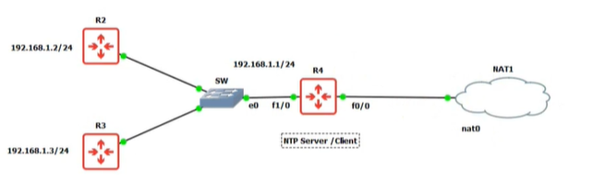

**R4 As Server For R2 & R3**

R4(config-if)#ip address dhcp [interface f0/0]

R4(config-if)#ip address 192.168.1.1 [interface e0/1]

R4(config)#ip name-server 8.8.8.8

R4(config)#ip domain-lookup

This uses google search engine for ip to name and name to ip.

R4#show clock

~00.00.37 UTC Fri Mar 1 2002

R4(config)# ntp server sa.pool.ntp.org

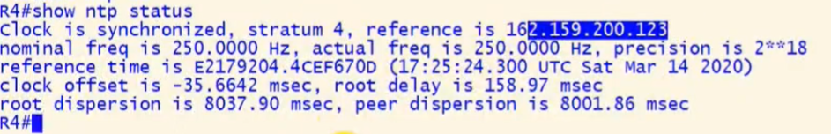

R4 is receiving time from 162.159.200.123 while the source and atomic clock has 2 more servers that’s why our R4 has stratum 4 means 3 more servers through the route to reach the atomic clock.

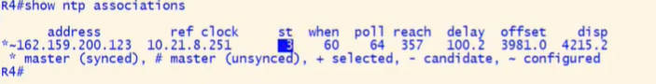

**Client Receiving Time:**

R2(config)# ntp server 192.168.1.1

